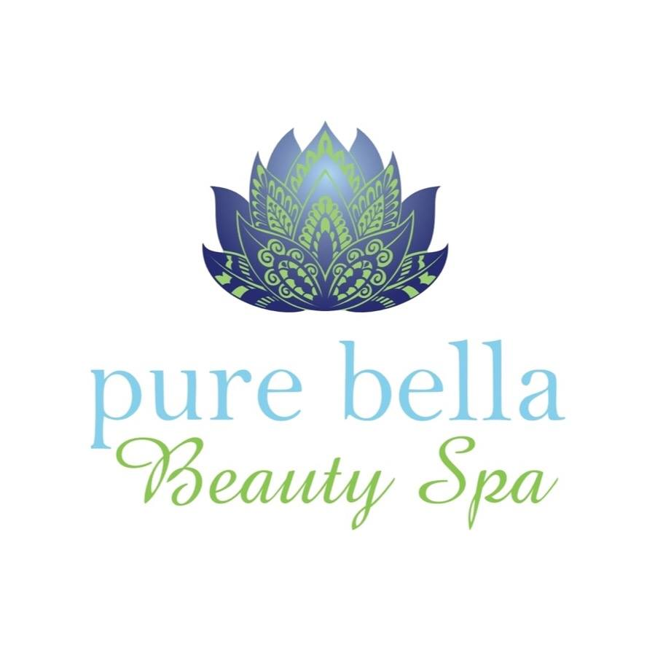

Client Consultation Form

Name: _______________________Surname: ___________________________

Email:___________________________________________________________

Mobile: __________________Tel no (Day): _____________________________

Address:_______________________________________________Date:______________________

This Consultation Form will assist your therapist in correctly evaluating your needs & choosing the correct treatment for you today.
All information is strictly confidential & remains the property of
Pure Bella Beauty Spa

♦ please indicate any recent or current experience of the following conditions:
Muscular/Joint High Risk |  | Illness/Tension | Circulatory
 Recent/Repetitive Injury |  Surgery |  Cold/Flu/Virus |  Blood Clots
 Joint Immobility |  Heart Problem/Pacemaker |  Chest/Breathing |  Thrombosis
 Numbness/Tingling |  High/Low Blood Pressure |  Asthma |  Varicose Veins
 Pain/Swelling |  Digestive Problems |  Headaches |  Oedema
 Fibromyalgia |  Diabetes or Epilepsy |  Dizziness |  Bruising
 Arthritis |  Cancer/Remission |  Sleeping Problems |  Gout
 Inflammation |  Covid 19 symptoms |  Depression
 Whiplash |  |  Anxiety

♦ please list any physical or health conditions that your therapist should be aware of

♦ | Please list any medication taken regularly and any specific medication/pain killers taken today
♦ | Any other additional information your therapist may need to know:

FACE & BODY SECTION

 Allergies |  Contact Lenses |  Skin Sensitivity |  Claustrophobia
 Pregnant/Breastfeeding |  Post Natal/Pre Menstrual |  Menopausal |  Heat Sensitivity
 Botox/ Dermal Fillers |  Chemical Peels |  Retin-A/ Retinol

GENERAL SECTION

- How many glasses of water caffeinated drinks ____________do you drinking a day?
- What type of exercise are you doing regularly _________hrs per week____?
- How do you feel today?  Energetic  Relaxed  Tired  Stressed  In Pain
- Have you had eye brow or lash tinting before? Yes/no

How did you hear about us?

 Word of Mouth |  Internet |  Walk by |  Advertising

Please agree to the terms and conditions below

 I confirm that to the best of my knowledge, the answers I have given are correct and I have not withheld any information that may be relevant to my treatment. I certify that the preceding medical, personal and skin history statements are true and correct. I am aware that it is my responsibility to inform my Therapist of my current medical or health conditions and to update this history as a current medical history is essential her/him to execute appropriate treatment procedures.

Client Signature: ____________________________________________

